**Movie Landing Page Website Design**

|  |  |
| --- | --- |
| **Name** | **: MAGHAM SAI AMAR** |
| **Email** | **: amarmagham@gmail.com** |
| **Roll NO** | **: 20HU1A0428** |

**College Name : Chebrolu engineering college**

**Phone number : 9392505708**

**source code:**

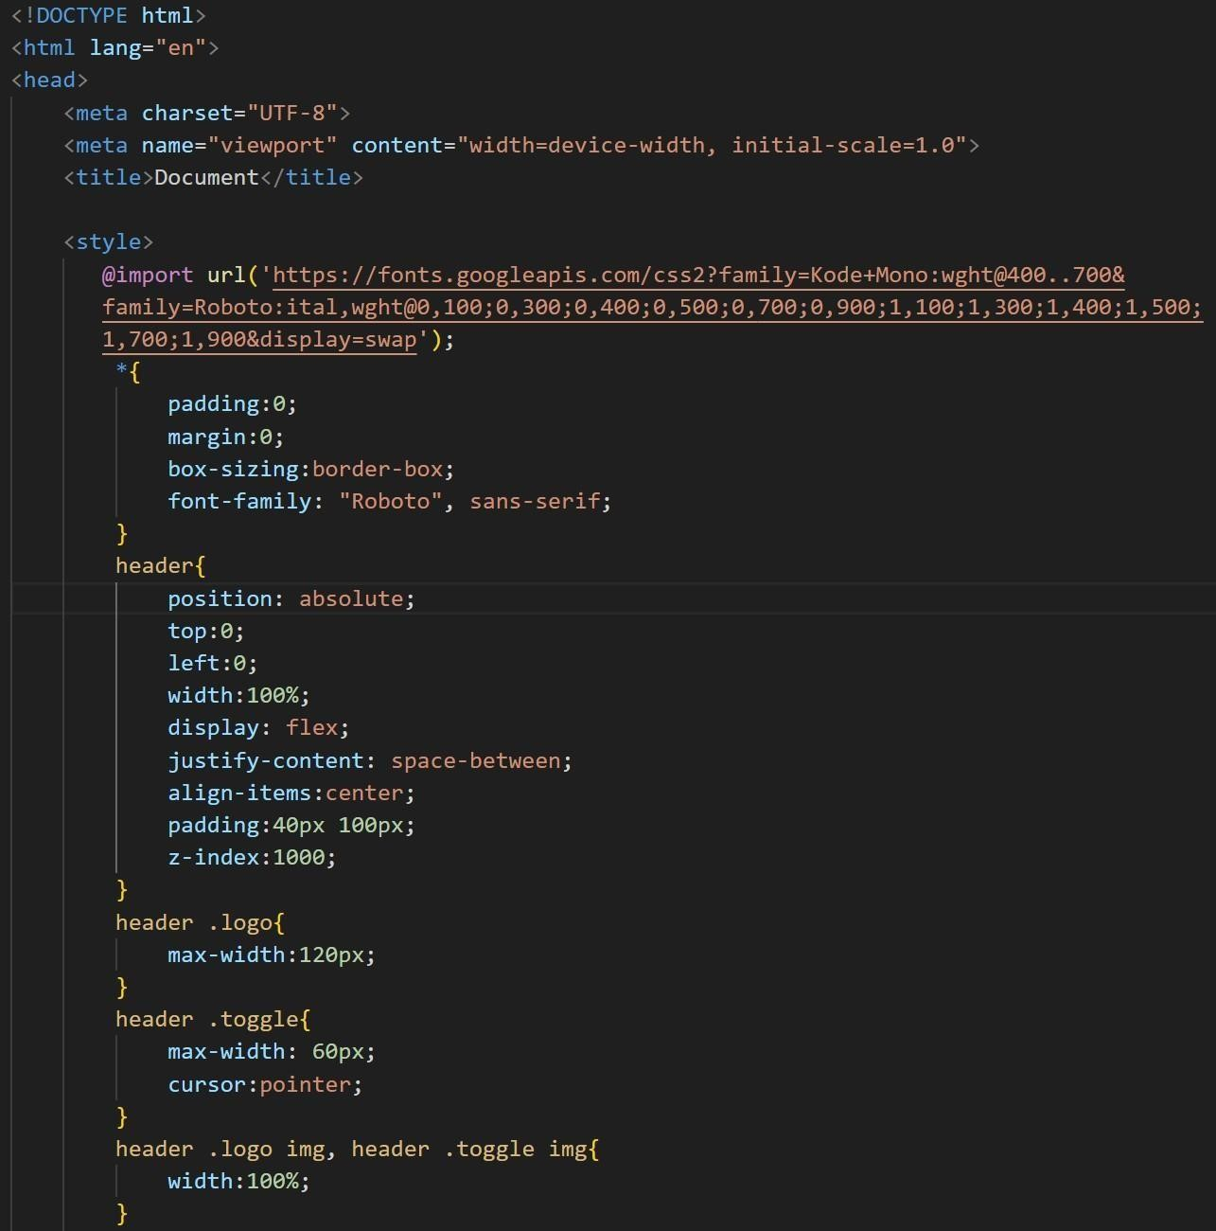

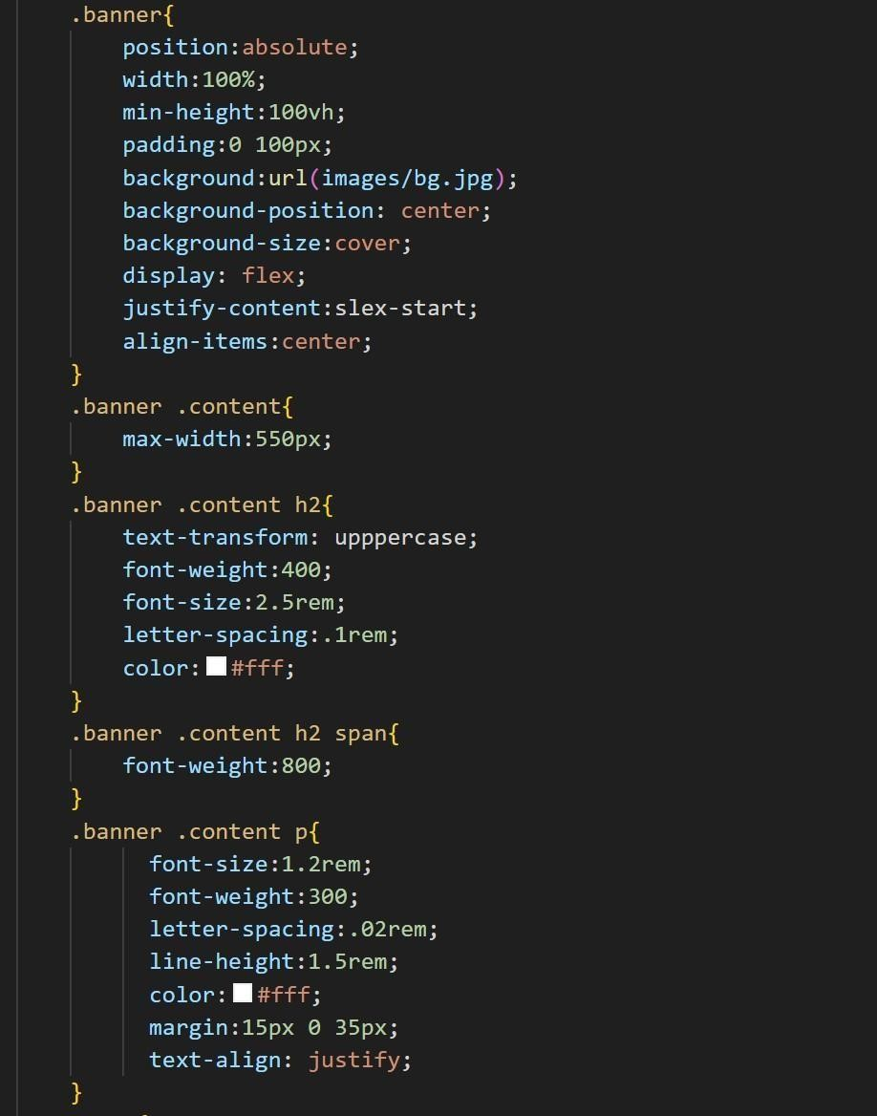

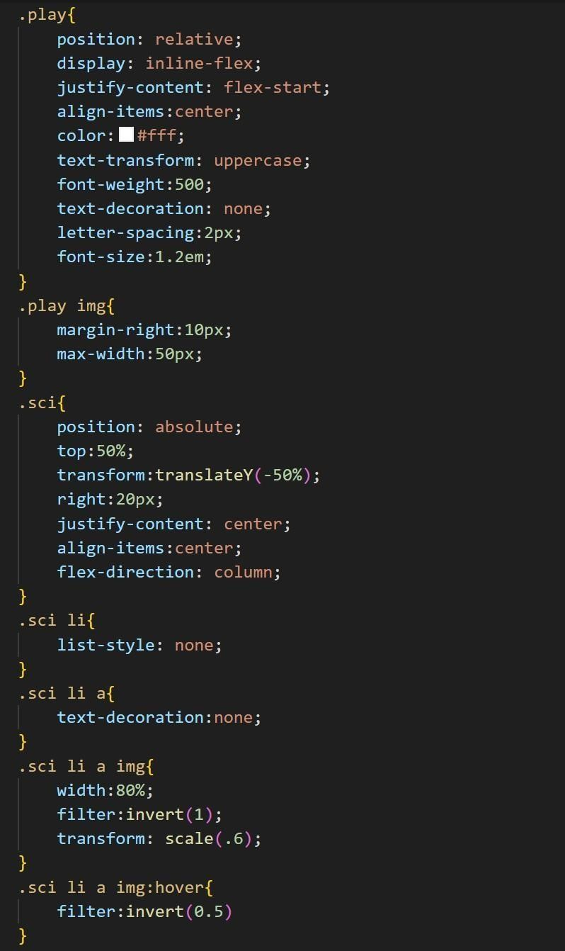

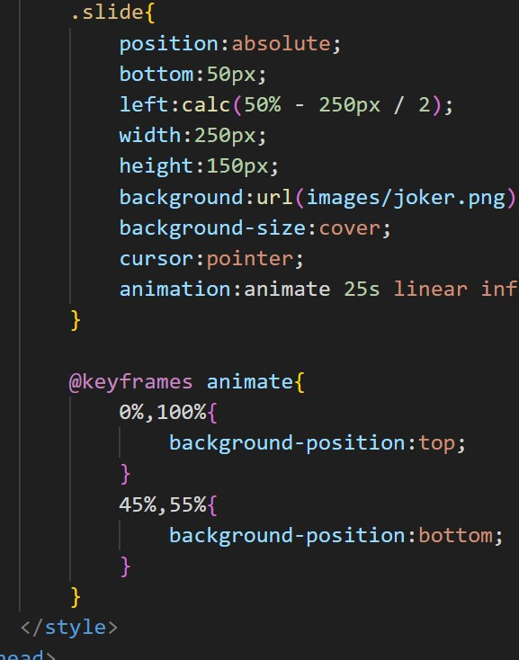

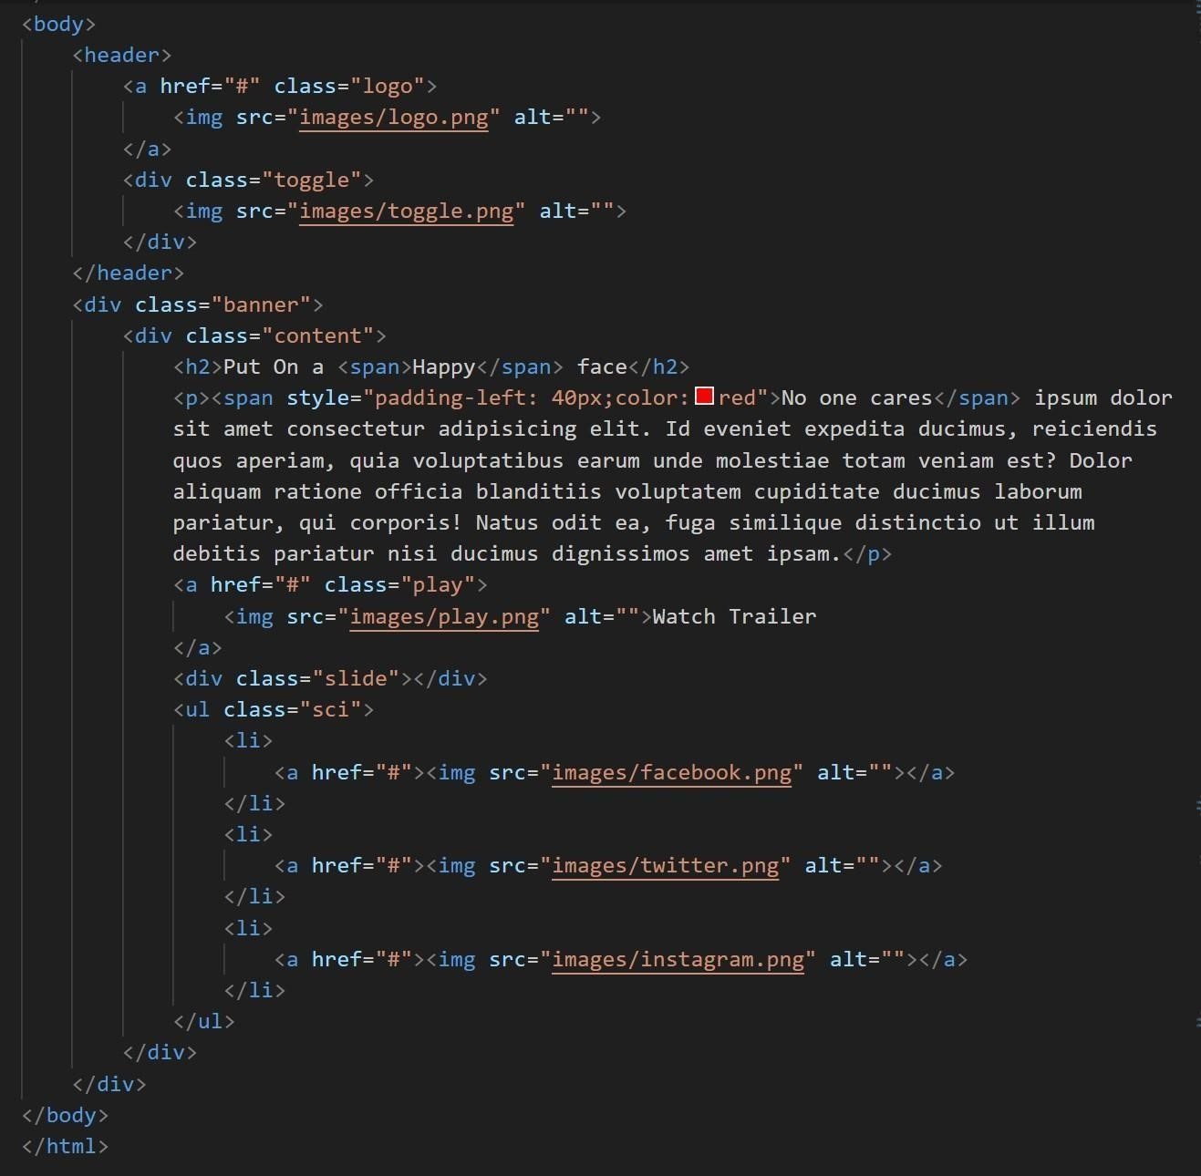

**flnal output :**

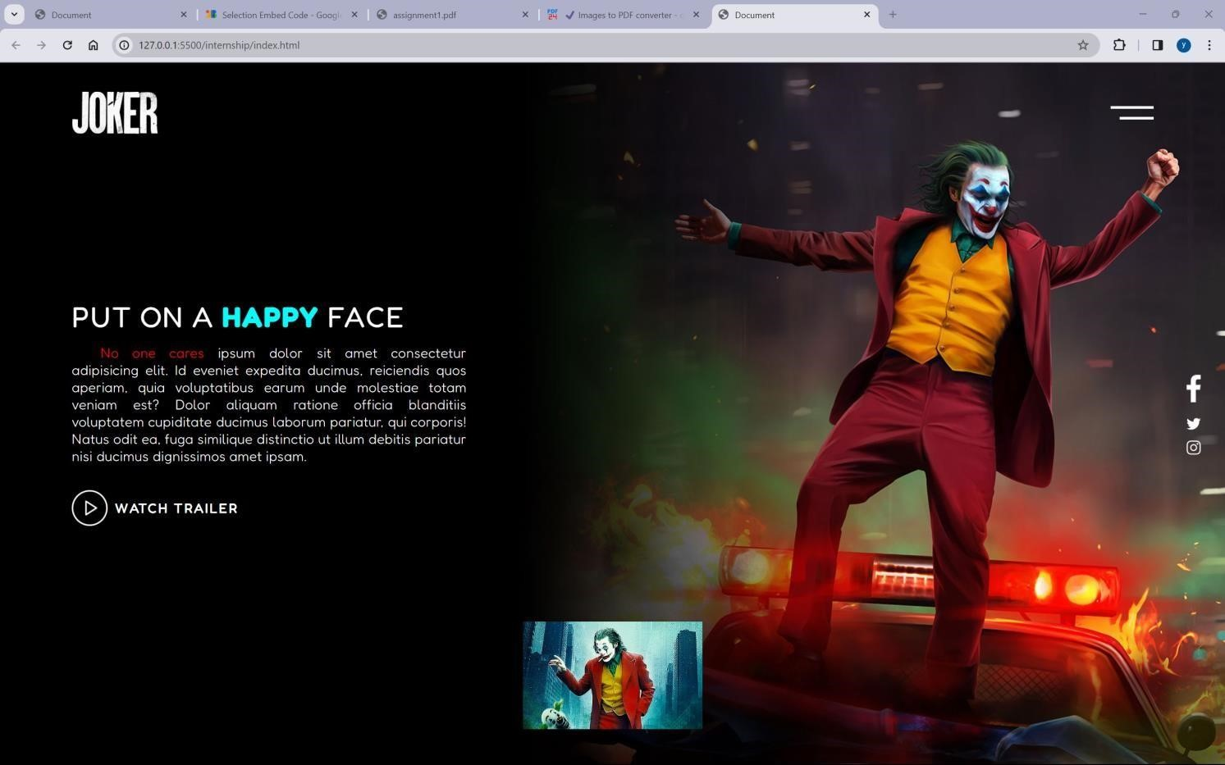

live demo : <https://4727yesuraju.github.io/static-webpage/>source code: <https://github.com/4727yesuraju/static-webpage>